

Planning Proposal

For

1. Rezoning of Lot 272 in DP 750170 and adjacent Crown road reserve, Hill Street (Mitchell Highway), Molong – being land currently zoned R1 General Residential by Cabonne Local Environmental Plan 2012 – to part B2 Local Centre and part RE1 Public Recreation, and
2. Including an additional clause into the Cabonne Local Environmental Plan 2012 to address boundary adjustments upon rural land where the lot is below the minimum lot size.

Prepared by Cabonne Council

July 2016

**CONTENTS**

**INTRODUCTION & BACKGROUND**

**PART 1 - OBJECTIVES OR INTENDED OUTCOMES**

**PART 2 – EXPLANATION OF THE PROVISIONS**

**PART 3 – JUSTIFICATION**

Section A – Need for the planning proposal

Section B – Relationship to strategic planning framework

Section C – Environmental, social and economic impact

Section D – State and Commonwealth interests

**PART 4 – MAPPING**

**PART 5 – COMMUNITY CONSULTATION**

**PART 6 – PROJECT TIMELINE**

**APPENDICES**

Appendix A – Director Environmental Services report and council minutes

Appendix B – Map of the sites to be reclassified

Appendix C – SEPPs checklist

Appendix D – Section 117 Directions checklist

**Introduction**

The Cabonne Local Environmental Plan (LEP) 2012 was implemented on 18 January 2013. As a result of the operation of the plan several matters have been identified that would benefit from a series of minor amendments.

The proposed changes to the LEP are as follows:

1. To rezone land at Molong from R1 General Residential to part B2 Local Centre and part RE1 Public Recreation. The LEP 2012 included a 556.4m² allotment of land described as Lot 272 in DP 750170 as zone R1 General Residential. Surrounding this allotment to its east and north is an irregular shaped area of land being a road reserve. This second parcel of land was also included in the R1 zone. To the west of the subject land is the Dr Ross Memorial Recreation Ground, and to the east of the subject area is open space / pubic recreation land leading to the Molong swimming pool. This adjacent land is zoned RE1 Public Recreation. To the north of the subject land is Molong Creek, while north of the creek lies farm land zoned RU1 Primary Production.

Prior to the implementation of Cabonne Local Environmental Plan 2012 the subject land was zoned 2(v) Village by the former Cabonne LEP 1991. A Development Control Plan (DCP 10 – Flood Prone Land in Molong) identifies the subject land as within the Molong floodway.

Situated upon Lot 272 in DP 750170 is a weatherboard building with a metal roof. Constructed in 1939 by the Molong Country Women’s Association (CWA) as its meeting/rest rooms and baby health clinic. The building served in this capacity for many years, and was utilised by other groups such as the Molong Red Cross. The property was sold in 2004 and development consent issued on 7 December 2004 for the use of, and extension to, the former CWA Hall for the purpose of a café.

The building was utilised as a café and a gallery / café until May 2015. The owner has actively been seeking a commercial tenant for the site, however the premises has now been vacant for over 12 months. Quite recently commercial inquiry has fostered fresh interest in the building as a restaurant / cafe. The Environmental Planning & Assessment Act and Regulations specify that ‘existing use’ rights are extinguished should an activity (that had lawfully commenced before a zoning change occurred that subsequently prohibited that land use) cease operation for a period of 12 months or more.

In this instance development consent for use of the premises as a café was lawfully granted and the business established accordingly. In January 2013 the Cabonne Local Environmental Plan 2012 was implemented, and the subject land was altered from 2(v) Village to R1 General Residential. The latter zone precludes ‘food and drink premises’ within the zone.

The suitability of the subject land for residential use is likely to be limited as: (a) the building was purpose built as a CWA community meeting room and later altered to accommodate a café with an outdoor dining deck,

(b) the allotment’s isolation from other residential development, and

(c) the proximity of the land to Molong Creek and associated flood issues.

It is therefore suggested that the transition zoning from 2(v) Village to R1 General Residential has in this instance created a planning land use anomaly and the land may more suitably be zoned B2 Local Centre to permit continued commercial use of the site.

Surrounding the former CWA hall land is a “L” shaped section of road reserve also currently zoned R1 General Residential. This land contains a large stormwater outlet pipe and a deep channel that connects to Molong Creek. The northern section of the road reserve drops steeply to the creek bed and forms the current bank to the creek. It is suggested that this land would more appropriately be zoned RE1 Public Recreation as it effectively forms part of the existing open space corridor.

1. To amend the Cabonne Local Environmental Plan 2012 by inserting an additional clause – being a model ‘boundary adjustment’ clause, to provide clarity for rationisation of allotment boundaries for rural zoned land for agricultural purposes, particularly where existing dwellings are situated upon rural lots below the minimum lot size.

The Planning Proposal addresses each of the items under its various Parts in the following report.

**Part 1 – Objectives or intended outcomes**

1. To rezone land at Molong from R1 General Residential to part B2 Local Centre and part RE1 Public Recreation. The intended outcome is to permit an appropriate range of land uses including continued commercial use of the former CWA Hall.
2. To allow for rationalization and consolidation of agricultural land to enhance agricultural sustainability.

**Part 2 – Explanation of provisions**

1. **Rezoning of Lot 272 DP 750170 and adjacent road reserve**

Following an approach from the owner of Lot 272 DP 750170, and following preliminary discussions with the Department of Planning and Environment a Planning Proposal has been prepared to amend the Cabonne Local Environmental Plan 2012 to remove a zoning anomaly. Council when reviewing the matter further identified that the land adjacent to Lot 272 being a road reserve was also affected by the zoning anomaly. It is proposed to rezone the subject land at Molong from R1 General Residential to part B2 Local Centre and part RE1 Public Recreation. The intended outcome is to permit a range of commercial land uses, including food and drink premises, for the former CWA Hall, and to zone a road reserve as part of the adjacent open space corridor.

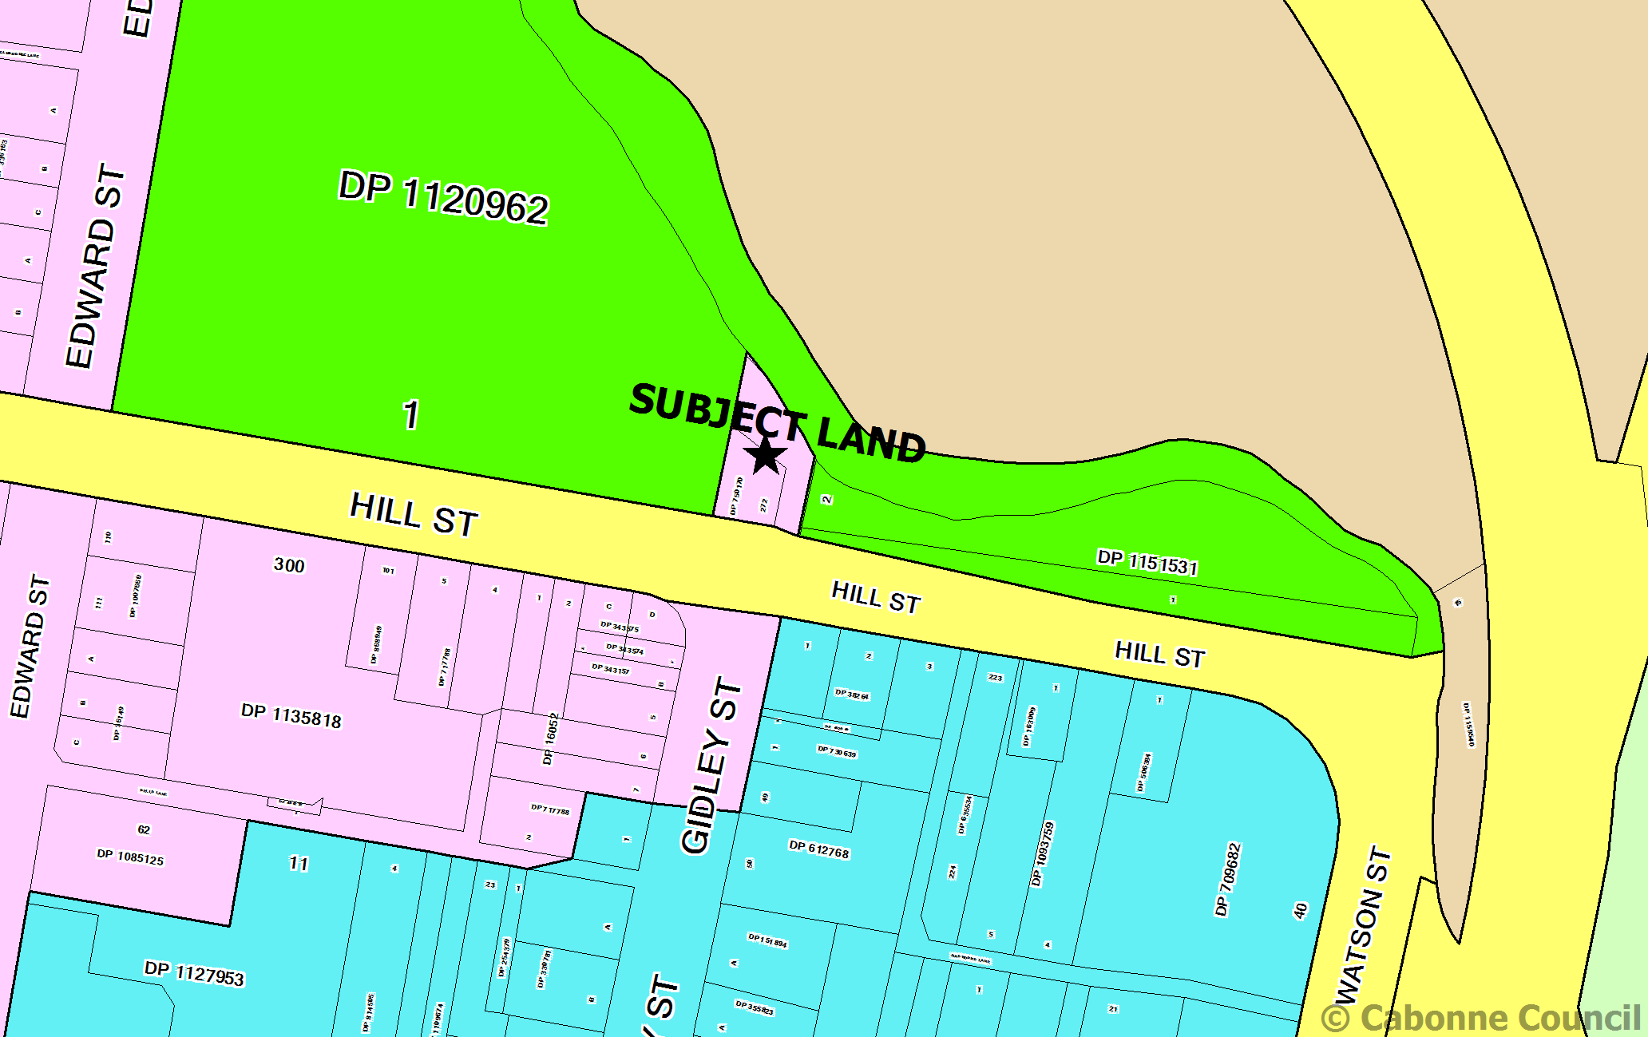

CLEP 2012 zoning and site plan

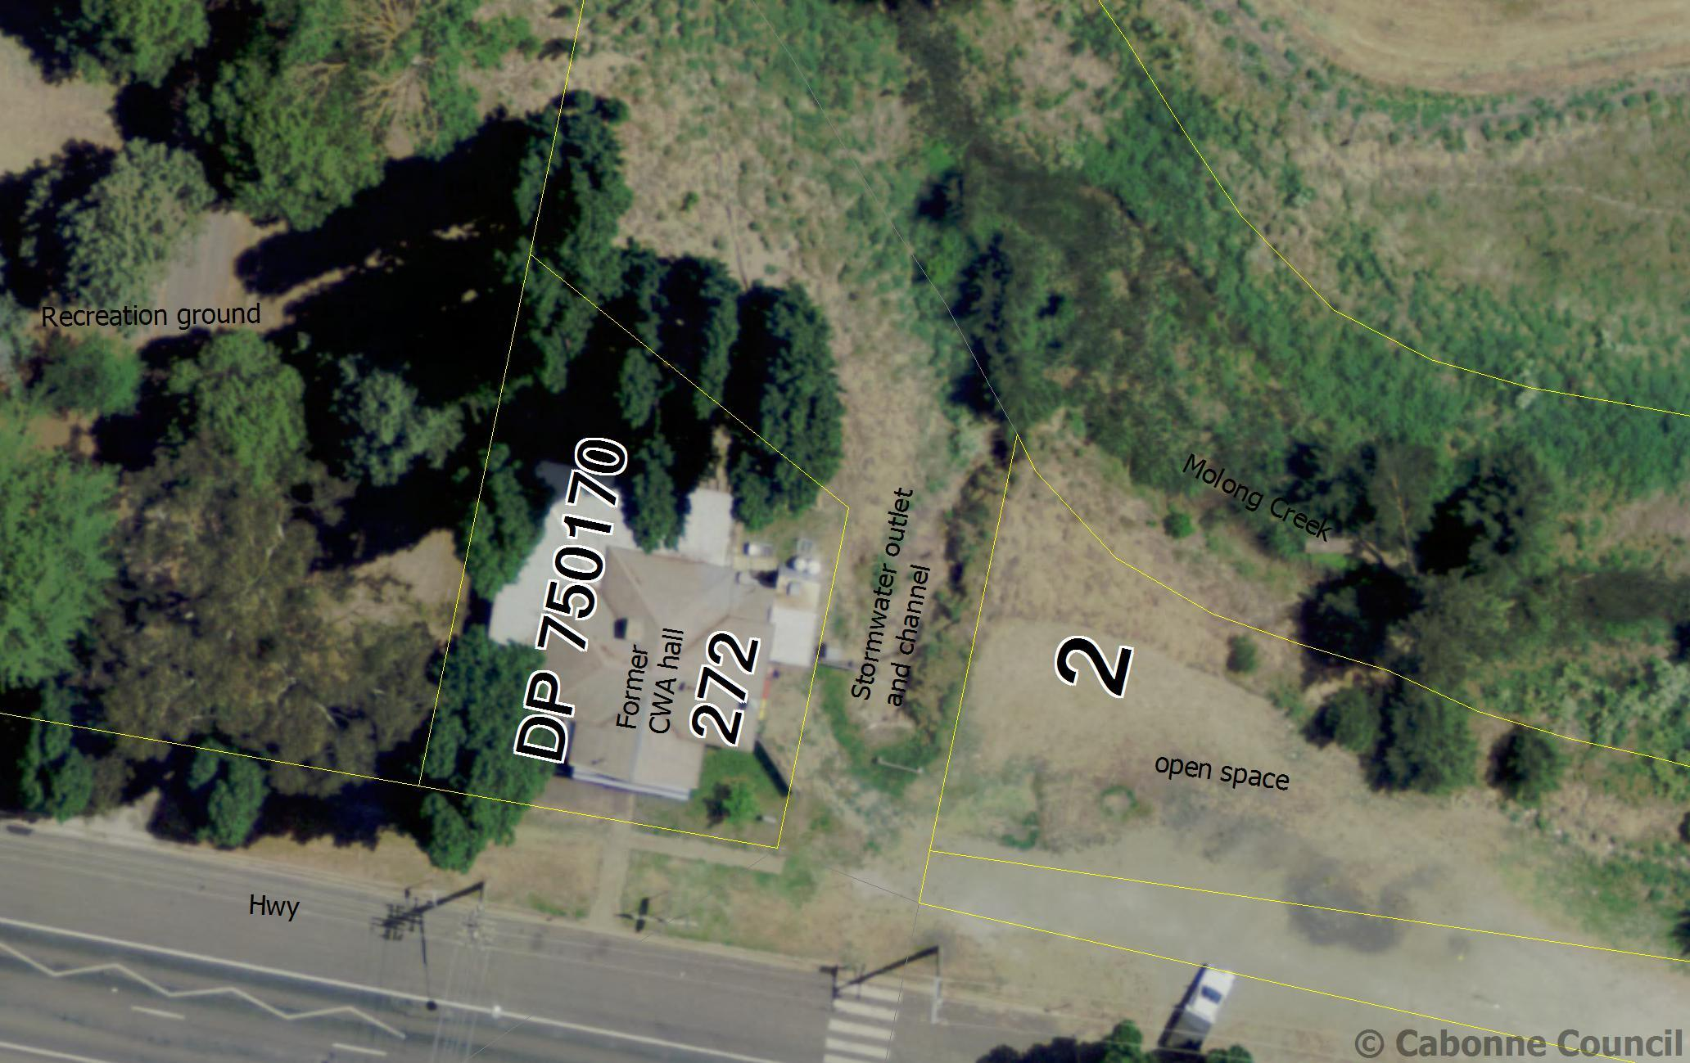Aerial map of subject land

It is suggested that Land Zoning Map – Sheet LZN_004A be amended to remove the zone R1 and replace it with zone B2 Local Centre over Lot 272 DP 750170 and RE1 Public Recreation over the adjacent road reserve. The Lot Size Map – Sheet LSZ_004A will also require amendment so that the subject area, currently shown as coloured green on the map (500m² minimum) is deleted and the land be shown as uncoloured on the mapping sheet.

1. **Inserting a rural boundary adjustment clause**

Since the implementation of the Cabonne Local Environmental Plan 2012 council has received an increasing number of enquires seeking to amend rural allotment boundaries generally between two existing allotments thereby increasing the area of the agricultural allotment while decreasing the area of land surrounding an existing dwelling - such that the dwelling lot by default equates to a lifestyle allotment. In other instances, proposals to adjust farm allotments as part of farm adjustments and transfer of agricultural land between adjoining land owners have agricultural merit, however where allotments are below the 100ha minimum lot size and contain an existing dwelling the LEP, Rural SEPP and Exempt Development SEPP do not align to enable clear planning principles for considering such requests.

Council adopted a Right to Farm policy in 2015 and strongly supports the State in this matter. Conflict arising from inappropriate land use, including friction arising from land use conflict between rural farm activity and lifestyle / concessional allotment land holders, is likely to increase within the Cabonne area hence the perceived need for a specific LEP clause to address boundary adjustments.

Council staff have reviewed the draft model clause of the Department and also the draft clause currently proposed for inclusion in Blayney Shire Council’s LEP which is based upon similar clauses included in LEPs for Griffith and Port Macquarie – Hastings councils.

It is proposed that Cabonne Council’s adopt an LEP amendment provision similar to that currently proposed by the adjacent council, Blayney Shire Council. The clause would apply to rural zones (RU1 Primary Production and RU2 Rural Landscape). The following wording is indicative (subject to legal review):

**4.2B Boundary adjustments in certain rural zones**

(1) The objective of this clause is to facilitate boundary adjustments between lots where one or more resultant lots so not meet the minimum lot size but the objectives of the relevant zone can be achieved.

(2) This clause applies to land in the following zones:

(a) Zone RU1 Primary Production,

(b) Zone RU2 Rural Landscape.

(3) Despite clause 4.1, development consent may be granted to subdivide land by way of a boundary adjustment between adjoining lots were one or more resultant lots do not meet the minimum lot size shown on the Lot Size Map in relation to that land if the consent authority is satisfied that:

1. The subdivision will not create additional lots or the opportunity for additional dwellings, and
2. The number of dwellings or opportunities for dwellings on each lot after subdivision will remain the same as before the subdivision, and
3. The potential for land use conflict affecting the ‘right to farm’ will not be increased as a result of the subdivision, and
4. If the land is in Zone RU1 Primary Production or Zone RU2 Rural Landscape – the agricultural viability of the land will not be adversely affected as a result of the subdivision.

**Part 3 – Justification**

**Section A – Need for the Planning Proposal**

**3.1 Is the Planning Proposal a result of any strategic study or report?**

The planning proposal is not the result of a specific study or report. The issues that the Planning Proposal addresses have been identified through operational experience with the new LEP and community feedback.

Refer to Appendix A and B.

**3.2 Is the Planning Proposal the best means of achieving the objectives or intended outcomes, or is there a better way?**

The Planning Proposal achieves the intended outcomes identified in Part 2.

1. The Planning Proposal addresses a minor zoning anomaly.
2. The Planning Proposal seeks to provide guidance to allow consolidation and rationalisation of rural land lot boundaries.

**3.3 Is the Planning Proposal consistent with the objectives and actions of the applicable regional or sub-regional strategy?**

The planning proposal is not inconsistent with the Blayney, Cabonne and Orange City council’s Sub-regional rural and industrial land use strategy, July 2008. The sub strategy applies to rural, industrial and environmental zoned land. The proposed minor amendments to the Cabonne Local Environmental Plan 2012 are not inconsistent with the strategy.

**3.4 Is the planning proposal consistent with council’s local strategy or other local strategic plan?**

The Planning Proposal is consistent with the Cabonne Community Strategic Plan and the 2012 Cabonne Settlement Strategy.

**3.5 Is the Planning Proposal consistent with applicable State Environmental Planning Policies?**

The planning proposal is consistent with State Environmental Planning Policies (SEPPs). Refer to Appendix C

**3.6 Is the planning proposal consistent with applicable Ministerial Directions (s117 directions)?**

The planning proposal is consistent with relevant Ministerial Directions (s117 directions). Refer to Appendix D.

**3.7 Is there any likelihood that critical habitat or threatened species, populations or ecological communities, or their habitats, will be adversely affected as a result of the planning proposal?**

1. The planning proposal for rezoning of land does not apply to land that has been identified as containing critical habitats or threatened species, populations or ecological communities, or their habitats.

2. Merit based assessment of rural subdivision development applications will take into account at that time any relevant assessment of Biodiversity, Riparian Lands and Waterways Maps contained within the Cabonne LEP 2012.

**3.8 Are there any other environmental effects as a result of the planning proposal and how are they proposed to be managed?**

1. The subject land is located on the banks of Molong Creek and is subject to flooding. Existing planning controls are in place to assess and manage development within the floodway, flood plain and flood fringe. The planning proposal does not alter the application of the existing controls.

2. Any environmental effects from boundary adjustment subdivision of rural land can be addressed through merit based assessment of development applications.

**3.9 Has the Planning Proposal adequately addressed any social and economic benefits?**

1. The minor nature of the Planning Proposal for rezoning will provide potential for social and economic benefit to the Molong community.

2. The Planning Proposal is not considered to have any significant social or economic effects.

**3.10 Is there adequate public infrastructure for the planning proposal?**

The planning proposal is unlikely to create any significant additional demands on public infrastructure.

**3.11 What are the views of State and Commonwealth public authorities consulted in accordance with the gateway determination?**

Initial advice from the Department of Planning and Environment indicated that a Planning Proposal is the appropriate process to implement the rezoning and the introduction of the boundary adjustment clause. No formal consultation has been carried out of other agencies at this time. Should the Gateway Determination identify any additional consultations, these would be undertaken.

**Part 4 – Mapping**

1. Molong - Lot 272 DP 750170 - R1 General Residential land to be rezoned B2 Local Centre (amendment to Land Zoning Map – Sheet LZN_004A) and removed from Minimum Lot Size Map (amendment to Lot Size Map – Sheet LSZ_004A)

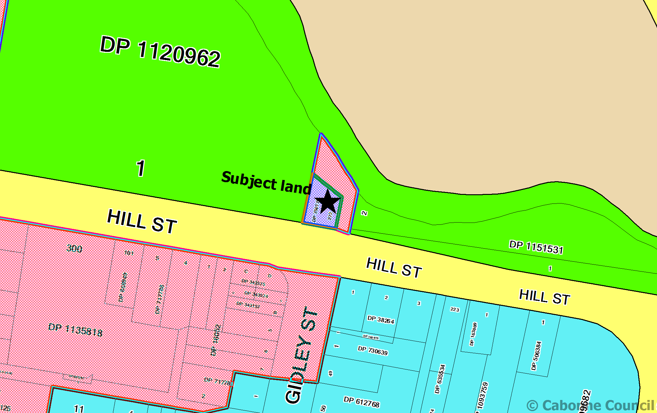

1. Molong – Road Reserve – R1 General Residential land to be rezoned RE1 Public Recreation (amendment to Land Zoning Map – Sheet LZN_004A) and removed from Minimum Lot Size Map (amendment to Lot Size Map – Sheet LSZ_004A)

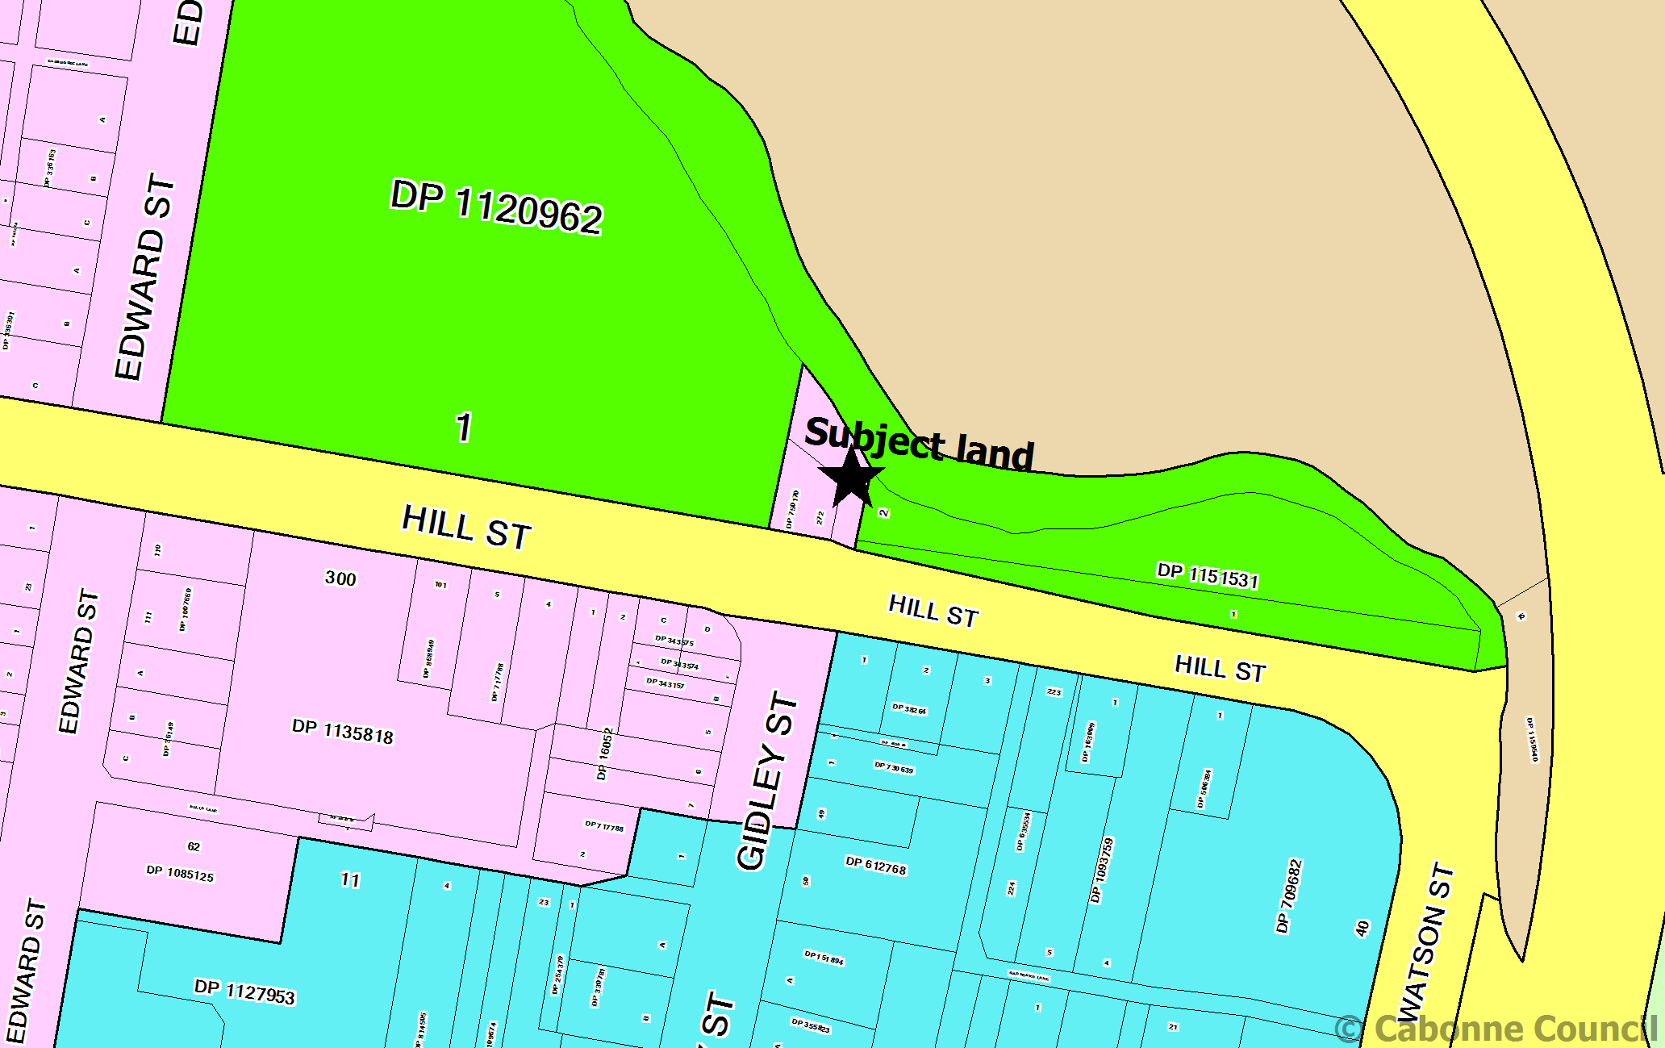

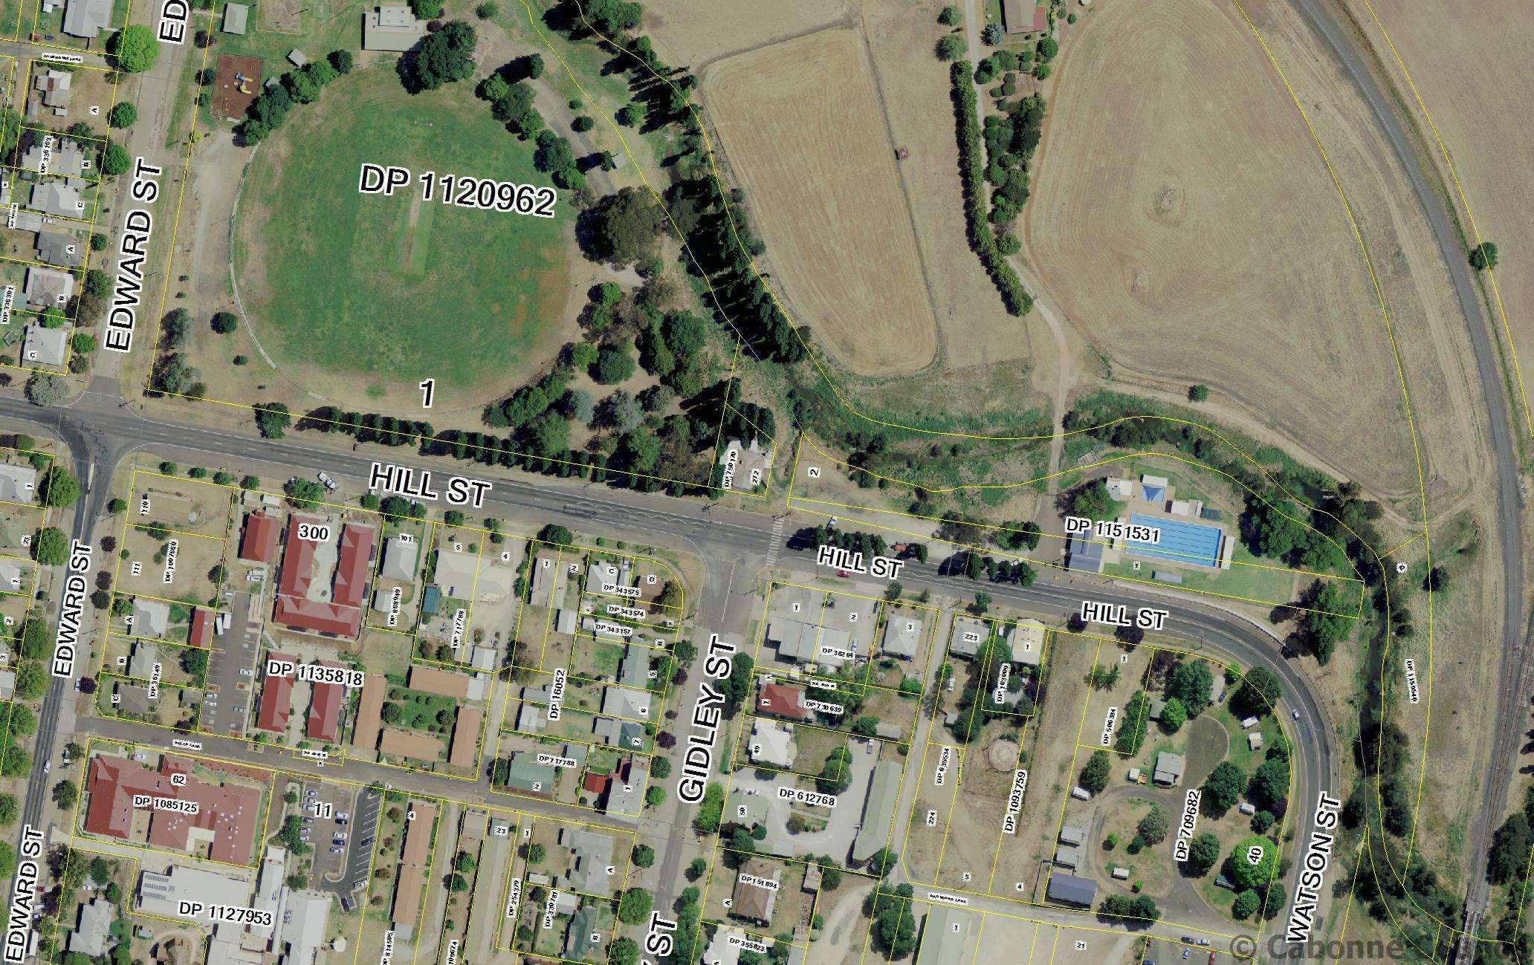Aerial image of subject land and surrounding precinct

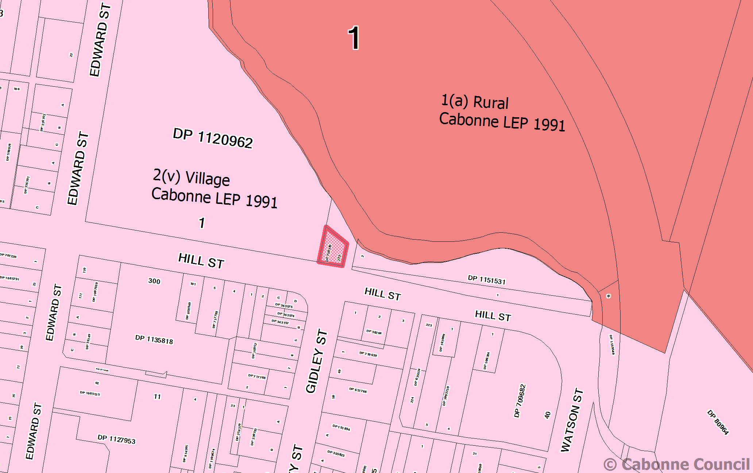**Extract – former Cabonne LEP 1991**

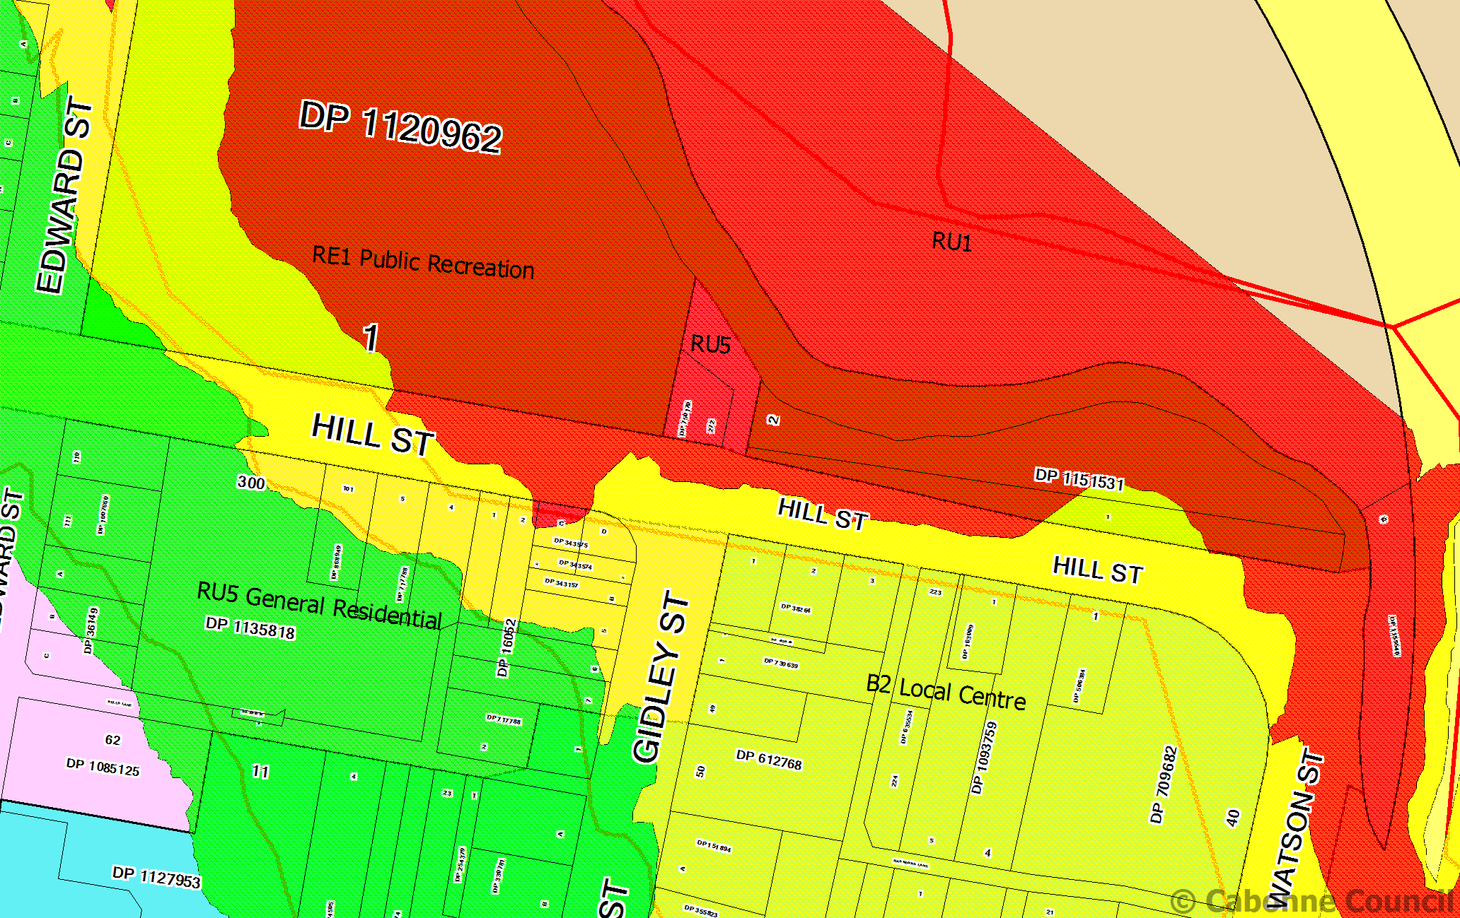**Extract - Flood map - Molong**

Key: Red – floodway 1in 20 year flood

Yellow – flood fringe 1 in 100 year flood

Green – Outer floodplain – 1 in 300 year flood

**Part 5 – Community consultation**

For the purpose of public notification, the planning proposal is considered that a 28 day exhibition period be held to ensure consultation with all stakeholders and any relevant government agencies.

1. The community consultation will involve:

* Notice in the local media / newspapers at the start of the exhibition period
* Notice on council’s web site for the duration of the exhibition period
* Written notification sent to landowners adjacent to the land proposed for rezoning
* Written notification to the Roads & Maritime Services (RMS)

1. The community consultation will involve:

* Notice in local newspapers at the start of the exhibition period
* Notice in the community newsletters during the exhibition period
* Notice on council’s web site for the duration of the exhibition period

The written advice will contain:

* A brief description of the objectives or intended outcomes of the planning proposal
* An indication of the land affected by the planning proposal
* Information on where and when the planning proposal can be inspected
* The contact details of the council for receipt of submissions
* The closing date for submissions

During the public exhibition period the following documents will be placed upon public exhibition:

* The planning proposal
* The Gateway Determination
* Relevant council reports

The above mentioned documents will be available at the following locations during the public exhibition period:

* Cabonne Council office – 101 Bank Street, Molong,
* Cabonne Council office – Main Street, Cudal
* Canowindra library – Gaskill Street, Canowindra

A public hearing will not be required to be held upon conclusion of the public exhibition phase.

Public exhibition of the Planning Proposal would be carried out in accordance with the requirements of the Environmental Planning & Assessment Act, Environmental Planning Regulations and the Gateway Determination.

**Part 6 – Project timeline**

The anticipated project timeline for completion of the Planning Proposal is outlined below:

|  |  |  |  |
| --- | --- | --- | --- |
| **No** | **Task** | **Commencement** | **Completion** |
| 1 | Gateway determination  Obtain Gateway Determination | August 2016 | August 2016 |
| 2 | Public Exhibition  Agency and community consultation to be undertaken as part of the formal public exhibition of the planning proposal in accordance with any conditions of the Gateway Determination | September 2016 | September 2016 |
| 3 | Consider submissions and document finalisation  Council staff to consider, respond and report to council on any submissions received and issues raised, and make any relevant changes to the planning proposal.  This process will determine amongst other things, the following:   * Whether or not to endorse and/or support the planning proposal * Whether or not to endorse the planning proposal (as exhibited); or * Whether or not to endorse the planning proposal (as amended) | October 2016 | November 2016 |
| 5 | Submission to the Department and/or Parliamentary Counsel  Council to forward the planning proposal to the department and/or Parliamentary Counsel following public exhibition (including and changes made). | November 2016 | December 2016 |
| 6 | Notification  Notification of LEP amendment being made | December 2016 | January 2017 |

**APPENDIX A**

**Planning report to Council 28 June 2016**

**Director of Environmental Services' REPORT**

Council has received the attached correspondence from Mr G and Mrs K Robbins requesting council consideration for rezoning of Lot 272 DP 750170, Hill Street, Molong, from R1 General Residential under the Cabonne Local Environmental Plan 2012 to B2 Local Centre.

The land is the site of the former CWA rooms, and more recently used as a café and an art gallery. Located on the northern side of Hill Street at the intersection of Hill and Gidley streets, the building is adjacent to the recreation ground, crown land and further to the east – the Molong Swimming Pool.

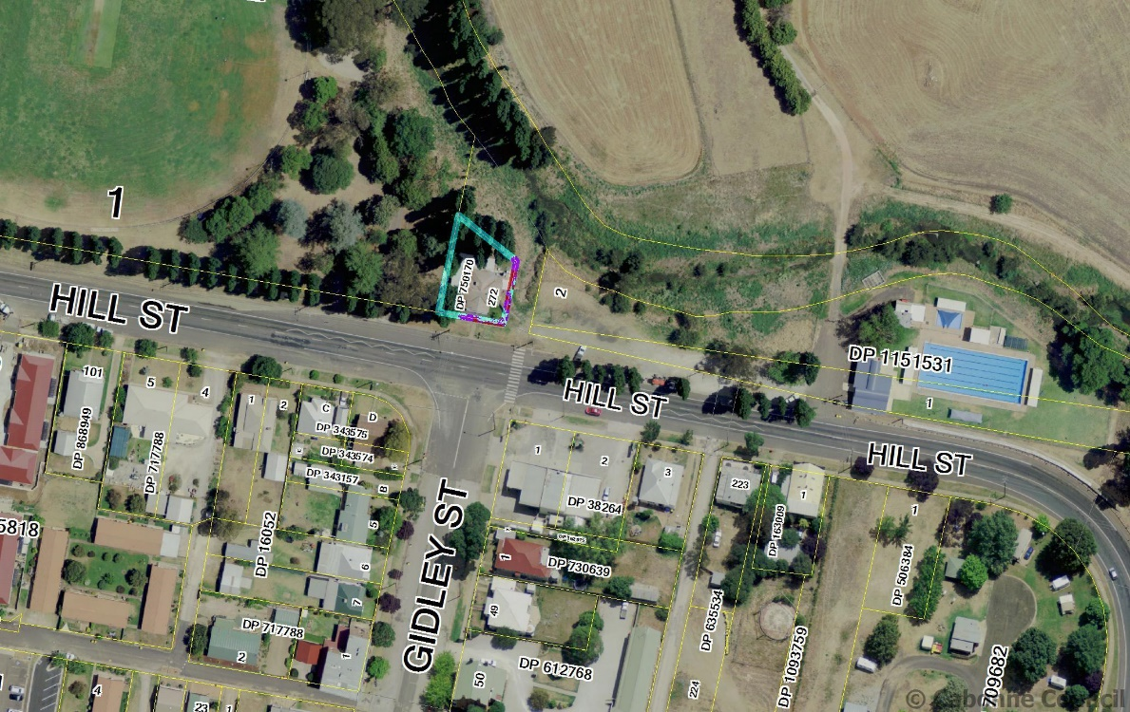

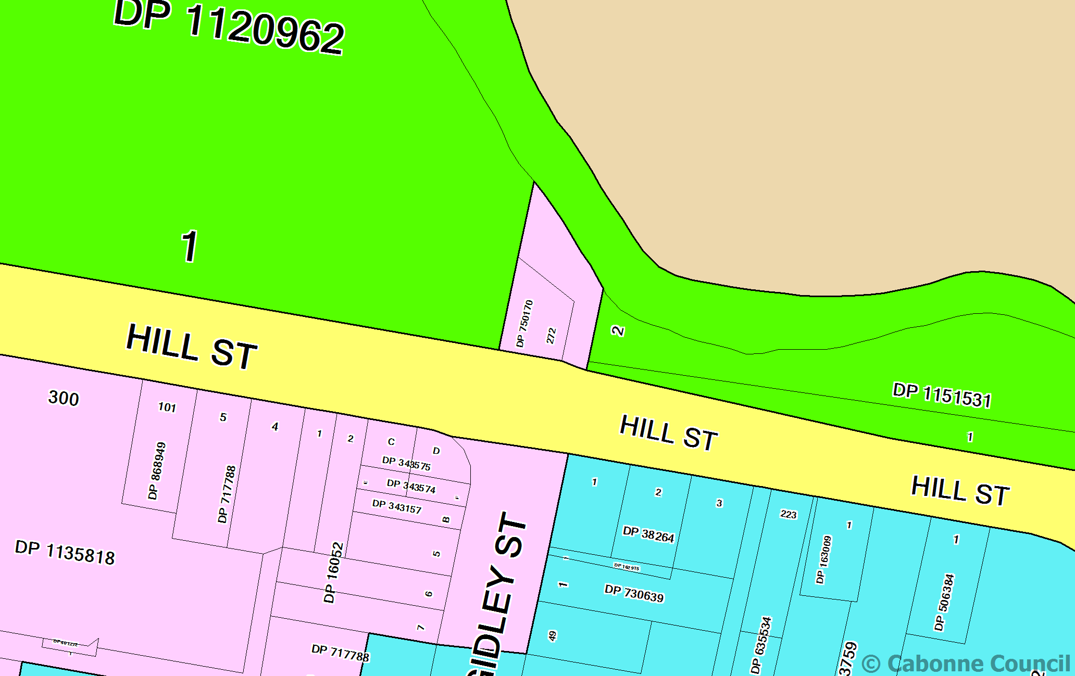

The property had enjoyed a ‘Village’ zone under the previous LEP. That zone permitted a broad range of residential, commercial and industrial uses within the zone subject to council’s development consent. In transitioning the former LEP to the Standard Model Instrument LEP the village zone was replaced by the R1 General Residential zone. The latter zone does not permit commercial or business uses within the zone.

At the time of the LEP review in 2010 to 2012 when the new LEP was implemented, the subject property continued to operate as either a café or more recently as an art gallery. The uses, lawfully commenced under the former planning scheme(s) was protected under the ‘Existing Use Rights’ provisions of the Environmental Planning & Assessment Act 1979 and associated regulation. Existing Use Rights enables land to continue to be used for an approved land use, even after the zoning of an area has been altered. However, once a land use ceases to operate for a period of twelve (12) months existing use rights are extinguished and land use permissibility is guided by the planning provision in place at that time.

The subject land had been protected by existing use right legislation at the time of implementation of the 2012 Cabonne LEP. The property had been leased and the situation arose of a vacant tenancy. A period of twelve months has since lapsed with the premise remaining vacant despite the owner’s efforts to secure a new commercial tenant.

The building was originally the Molong CWA rooms. As a structure the building has had a commercial use. The current LEP restricts the future lawful use of the building generally to that of a residence.

The land owner is requesting that council consider rezoning the single allotment of land to a commercial spot rezoning to enable the site to continue to be used for business / commercial uses in order to address an anomaly brought about by the transition to the current LEP. Given the isolated nature of the subject land it appears unlikely that the building would be altered and utilised as a residential dwelling.

It is noted that an area of reserve located east and north of the subject land is also zoned for residential use. It is suggested that should the adjacent land be rezoned, that the reserve land also be removed from the R1 General Residential zone and be back zoned as recreational land.

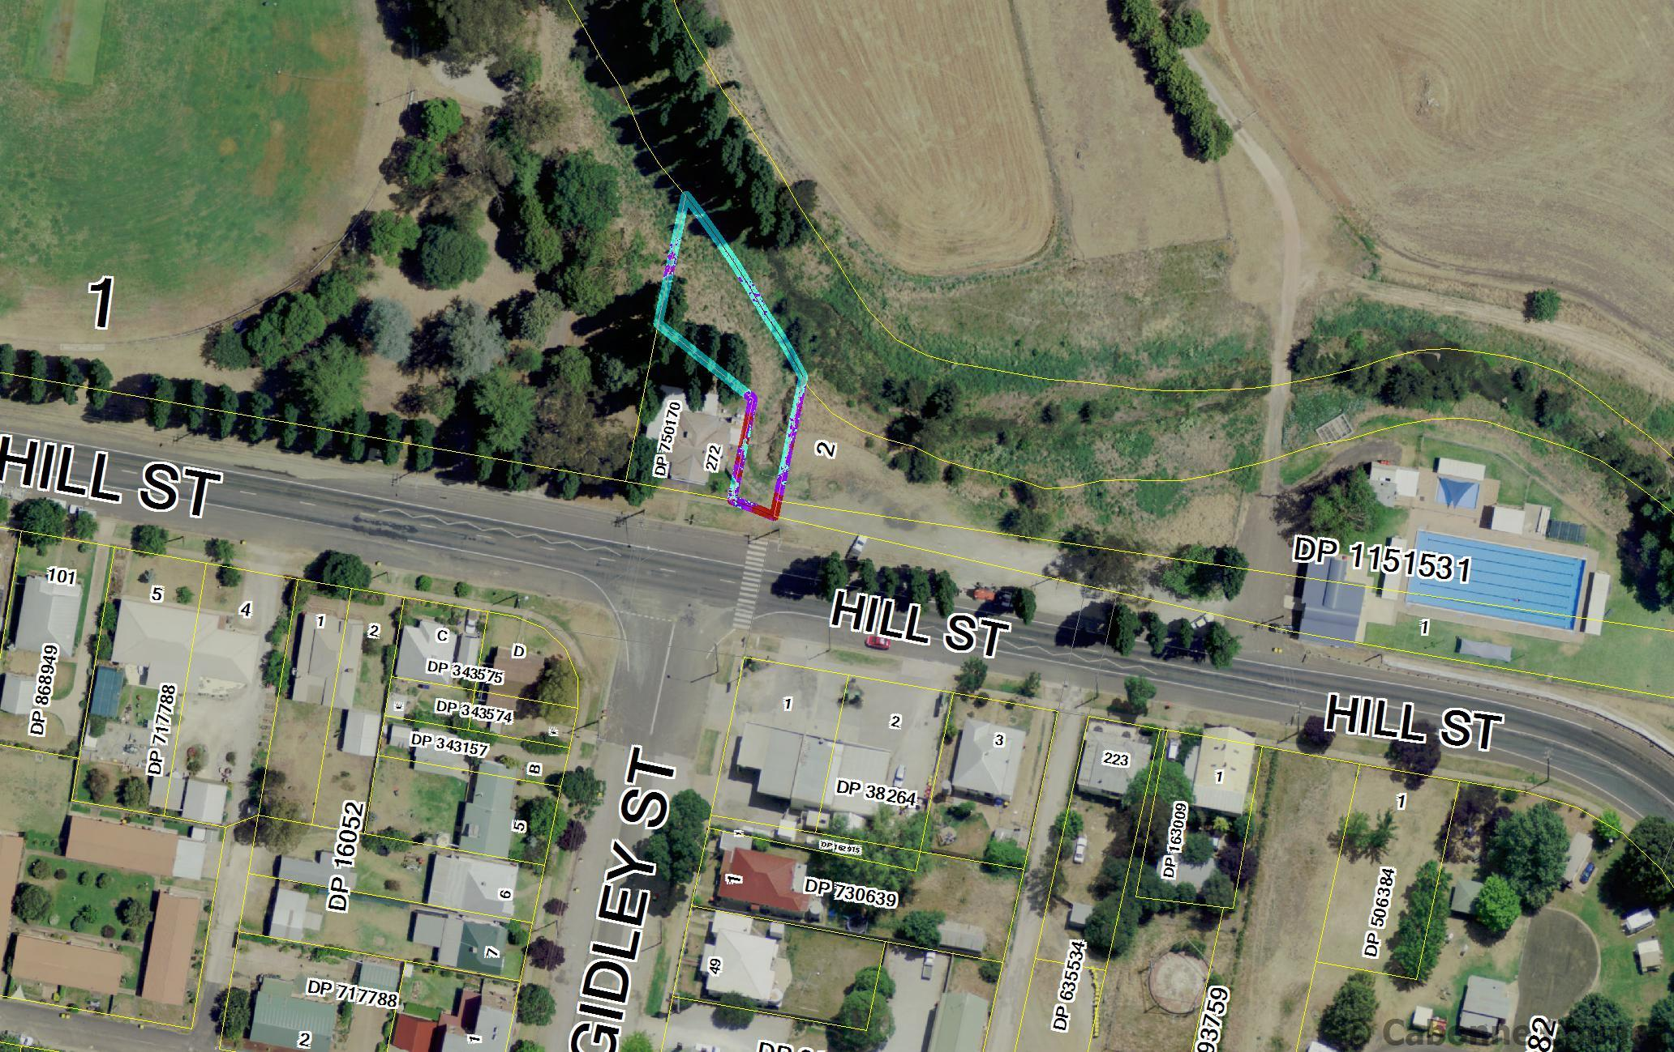

Please note that guidelines have been issued under Section 23A of the Local Government Act titled “*Council decision making during merger proposal periods*”. Council must consider the guidelines in relation to each decision they make during the proposal period, this matter is of an ongoing nature (being a proposed spot rezoning to amend a planning anomaly) and it is considered it complies with the guidelines.

**Recommendation**

THAT:

1. Council support the request from G & K Robbins to amend the Cabonne Local Environmental Plan 2012 to correct a planning anomaly by rezoning Lot 272 in DP 750170, Hill Street, Molong from R1 General Residential to B2 Local Centre,
2. Council prepare a Planning Proposal for rezoning of Lot 272 in DP 750170, and the adjacent reserve land, currently zoned R1 General Residential to be zoned B2 Local Centre (Lot 272) and RE1 Public Recreation, respectively,
3. The Planning Proposal be forwarded to the Department of Planning and Infrastructure for Gateway Determination in accordance with section 56 of the Environmental Planning & Assessment Act, 1979, and
4. A further report be provided to council following the public exhibition period to provide details of any submissions received.

**Extract from Council Minutes of meeting of 28 June 2016:**

|  |
| --- |
| **ITEM - 19 REQUEST TO REZONE LAND BEING LOT 272 DP 750170, HILL STREET, MOLONG** |
| **MOTION** (Culverson/MacSmith)  THAT:  1. Council support the request from G & K Robbins to amend the Cabonne Local Environmental Plan 2012 to correct a planning anomaly by rezoning Lot 272 in DP 750170, Hill Street, Molong from R1 General Residential to B2 Local Centre,  2. Council prepare a Planning Proposal for rezoning of Lot 272 in DP 750170, and the adjacent reserve land, currently zoned R1 General |

**Planning report to council 28 April 2015**

Recommendation

**DIRECTOR OF ENVIRONMENTAL SERVICES' REPORT**

The Cabonne Local Environmental Plan (CLEP) 1991(as amended) was

replaced in January 2012 by the Standard Instrument Cabonne Local

Environmental Plan 2012. The latter plan, following NSW State Government

guidelines, standardised the format and contents of the Cabonne planning

code. In doing so the new LEP removed the previous local provisions from the

planning process.

**Subdivision character / lot yield**

Prior to the implementation of CLEP 2012 the area of land west of the Spring

Hill village was zoned as rural residential with a specific restriction imposed

limiting the creation of allotments within the precinct to 22 lots based upon the

environmental constraints of the area.

The area was subdivided in accordance with the LEP and the Environmental

Impact Study that had informed the rezoning process at that time. Land

owners purchased their land aware of the limitations for further development

and that no further subdivision would occur. The allotments have since been

developed in accordance with the CLEP 1991 provisions and a certain

character established for the area.

In the zone conversion applying to CLEP 2012 the Spring Hill land was zoned

R5 Large Lot residential. A standard minimum lot size of 2ha was applied.

Council has received applications from several land owners now seeking to

re-subdivide allotments in the subdivision, based upon the numerical criteria

of the current LEP’s minimum lot size map. There has been no change to the

environmental constraints to the land that triggered the initial lot yield

maximum. Hence the environmental considerations that applied to the land at

initial rezoning and subsequent subdivision remain valid concerns.

Having now had opportunity to test the standard instrument LEPs, and

consequent to local government feedback, the Department of Planning has

been approachable to the submission of planning proposals that seek to

amend the standard instrument LEPs provisions on case specific matters.

Likewise the department is receptive to considering amending LEPs to include

provisions that establish an averaging clause – being legal wording included

in an LEP that establishes a set lot yield for a prescribed area.

It is suggested that council prepare a planning proposal for submission to the

Department of Planning through its Gateway Process to amend the CLEP

2012 to reflect an averaging clause applicable to the Spring Hill R5 zone to

protect the existing development character by restricting further subdivision or

re-subdivision of the precinct.

Preliminary discussions with the Department of Planning indicate its support

for the proposed planning amendment to address the character of the

developing precinct, and to enable sound management of environmental

constraints impacting upon the land.

**Boundary adjustments**

The Rural Lands State Environmental Planning Policy (SEPP) 2008 removed

concessional allotment provisions from all NSW planning schemes. The

introduction of the standard instrument Local Environmental Plan model has

further altered previous local planning provisions. As a result council is noting

emerging trends in development enquiries, with land owners seeking

innovative ways to vary rural allotment size and shape. The most common

enquiry relates to undertaking boundary adjustments using a State Planning

Policy (Rural Lands SEPP principle and Exempt and Complying provisions).

Basically a boundary adjustment relates to minor adjustments between two or

more rural lots. Enquires however more recently looking at boundary

adjustments to undertake subdivisions that are otherwise not permissible ie

adjusting two rural allotments to create a lifestyle lot around an existing

dwelling. A boundary adjustment should not be used to endeavour to create

land title that otherwise is not permissible.

The Department of Planning has development sample clauses that provide

greater direction as to the role and function of a boundary adjustment. It is

suggested that council consider amending the LEP to introduce a specific

clause addressing boundary adjustments. This amendment will have the

benefit of providing greater clarity for all parties, and enhance to the council

measures to manage development and subdivision for rural lands.

**RECOMMENDATION**

THAT council prepare a Planning Proposal, and pursuant to section 59 of the

Environmental Planning & Assessment Act 1979, council forward the Planning

Proposal to the Department of Planning and Infrastructure for the Minister to

make a Local Environmental Plan to implement a lot yield maximum of 23 lots

to the R5 land located west of the village of Spring Hill, and to implement a

clause within the shire wide LEP to address boundary adjustments.

**Extract from Minutes of Cabonne Council Meeting of 28 April 2015:**

|  |  |
| --- | --- |
| **ITEM - 29 SPRING HILL LARGE LOT RESIDENTIAL ZONE** | |
| Proceedings in Brief  Clr Gosper wanted it noted that he supports the motion. | |
| **MOTION** (Culverson/Wilcox)  THAT council prepare a Planning Proposal, and pursuant to section 59 of the Environmental Planning & Assessment Act 1979, council forward the Planning Proposal to the Department of Planning and Infrastructure for the Minister to make a Local Environmental Plan to implement a lot yield maximum of 23 lots to the R5 land located west of the village of Spring Hill, and to implement a clause within the shire wide LEP to address boundary adjustments. | |
| 15/04/30 | Carried  The Chair called for a Division of Council as required under Section 375A (3) of the Local Government Act which resulted in a vote for the motion (noting the absence of Clrs Davison, Treavors and Durkin – apologies) as follows  For: Clrs Nash, Wilcox, Smith, Gosper, MacSmith, Dean, Walker and Culverson |

Minute 15/04/30

**Note**:

Subsequent to Land & Environment Court appeals lodged over council’s refusal of two subdivision applications for land within the RU5 zone at Spring Hill, the resolution of council relating to the RU5 land at Spring Hill cannot be implemented. A further report to council addressed the court challenge and the mediated outcome in those matters.

The report as provided above also contains the initial council consideration to amend the CLEP 2012 to more adequately address the issue of rural boundary adjustment provisions.

**APPENDIX B**

**MOLONG SUBJECT LAND PHOTOGRAPHS**

|  |  |
| --- | --- |
| C:\Users\nichollh\AppData\Local\Microsoft\Windows\INetCache\Content.Word\photo.jpg  Former CWA Hall | C:\Users\nichollh\AppData\Local\Microsoft\Windows\INetCache\Content.Word\photo 1.jpg |
| C:\Users\nichollh\AppData\Local\Microsoft\Windows\INetCache\Content.Word\photo 3.jpg | C:\Users\nichollh\AppData\Local\Microsoft\Windows\INetCache\Content.Word\photo 2.jpg  Subject land viwed from NW |
| C:\Users\nichollh\AppData\Local\Microsoft\Windows\INetCache\Content.Word\photo 1.jpg | C:\Users\nichollh\AppData\Local\Microsoft\Windows\INetCache\Content.Word\photo 2.jpg  Stormwater channel |

|  |  |
| --- | --- |
| C:\Users\nichollh\AppData\Local\Microsoft\Windows\INetCache\Content.Word\photo 1.jpg | C:\Users\nichollh\AppData\Local\Microsoft\Windows\INetCache\Content.Word\photo 1.jpg  RE1 land to the east of the subject land |
| C:\Users\nichollh\AppData\Local\Microsoft\Windows\INetCache\Content.Word\photo 2.jpg  B2 Local Centre zoned land to south of subject land | C:\Users\nichollh\AppData\Local\Microsoft\Windows\INetCache\Content.Word\photo 3.jpg  R1 General Residential zoned land to south west of the subject land |
| C:\Users\nichollh\AppData\Local\Microsoft\Windows\INetCache\Content.Word\photo 2.jpg  Recreation Ground to immediate west of former CWA hall | C:\Users\nichollh\AppData\Local\Microsoft\Windows\INetCache\Content.Word\photo.jpg  Proximity of site to flood waters – 20 July 2016 |

**APPENDIX C**

**State Environmental Planning Policies (SEPP) checklist**

|  |  |  |  |
| --- | --- | --- | --- |
| **No.** | **SEPP Title** | **Applicable to Planning Proposal** | **Consistency** |
| 1 | Development Standards | No – does not apply to land in Cabonne Local Government Area (LGA) since implementation of Cabonne Local Environmental Plan (LEP) 2012 | N/A |
| 4 | Development without consent – Miscellaneous exempt & complying development | No – does not apply to land in Cabonne Local Government Area (LGA) since implementation of Cabonne Local Environmental Plan (LEP) 2012 | N/A |
| 6 | Number of storeys in a building | Not applicable | N/A |
| 14 | Coastal wetlands | Not applicable | N/A |
| 15 | Rural land sharing communities | Not applicable | N/A |
| 19 | Bushland in urban areas | Not applicable | N/A |
| 21 | Caravan Parks | Not applicable | N/A |
| 22 | Shops and commercial premises | Not applicable | N/A |
| 26 | Littoral rainforests | Not applicable | N/A |
| 29 | Western Sydney Recreation Area | Not applicable | N/A |
| 30 | Intensive agriculture | Not inconsistent with SEPP | Yes |
| 32 | Urban Consolidation (Redevelopment of urban land) | Not applicable | N/A |
| 33 | Hazardous and Offensive industry | Not applicable | N/A |
| 36 | Manufactured home estate | Not applicable | N/A |
| 39 | Split Island Bird Habitat | Not applicable | N/A |
| 44 | Koala Habitat Protection | Not applicable to the Molong rezoning. Consistent with the objective to conserve land forming part of a national park. | Yes |
| 47 | Moore Park Showground | Not applicable | N/A |
| 50 | Canal Estate Development | Not applicable | N/A |
| 52 | Farm dams and other works in land and waste management plan areas | Not applicable | N/A |
| 55 | Remediation of land | Not applicable to rezoning. Should future development including subdivision of existing industrial sites occur SEPP 55 will apply to development assessment | Yes |
| 59 | Central Western Sydney Regional Open Space and Residential | Not applicable | N/A |
| 60 | Exempt & Complying Development | No – does not apply to land in Cabonne Local Government Area (LGA) since implementation of Cabonne Local Environmental Plan (LEP) 2012 | N/A |
| 62 | Sustainable aquiculture | Not applicable | N/A |
| 64 | Advertising and signage | Not applicable | N/A |
| 65 | Design Quality of residential flat development | Not applicable | N/A |
| 70 | Affordable housing | Not applicable | N/A |
| 71 | Coastal protection | Not applicable | N/A |
|  | Affordable renting housing | Not applicable | N/A |
|  | Building Sustainability Index:BASIX 2004 | Not applicable | N/A |
|  | Exempt and Complying Development Codes 2008 | Not applicable | Yes |
|  | Housing for seniors and people with a disability 2004 | Applicable | Yes |
|  | Infrastructure 2007 | Applicable | Yes |
|  | Kosciuszko National Park Alpine Resorts 2007 | Not Applicable | N/A |
|  | Major Developments 2005 | Not applicable | N/A |
|  | Mining, Petroleum Production and Extractive Industries | Applicable | Yes |
|  | Rural lands 2008 | Applicable | Yes |
|  | State & regional development 2011 | Not applicable | N/A |
|  | Sydney Drinking Water Catchment 2011 | Not applicable | N/A |
|  | Sydney Region Growth Centres 2006 | Not applicable | N/A |
|  | Temporary Structures 2007 | Not applicable | N/A |
|  | Urban Renewal 2010 |  |  |
|  | Western Sydney Employment Area 2009 | Not applicable | N/A |
|  | Western Sydney Parklands 2009 | Not applicable | N/A |

**APPENDIX D – SCHEDULE OF SECTION 117 DIRECTIONS**

|  |  |  |  |
| --- | --- | --- | --- |
| 1. **Employment and resources** | | | |
| No. | Direction Title | Compliance | Comment |
| 1.1 | Business and industrial zones | Yes | No impact by the proposal processing |
| 1.2 | Rural zones | Yes | No change of rural zoning or additional development is proposed by this plan upon rural land |
| 1.3 | Mining, petroleum production and extractive industries | N/A | No changes to these industries are proposed |
| 1.4 | Oyster aquaculture | N/A | Does not apply to the land within the proposal |
| 1.5 | Rural lands | Yes | No impact on minimum existing rural lot size |
| 1. **Environment and heritage** | | | |
| 2.1 | Environmental Protection zones | Yes | No change to environmental protection zones proposed |
| 2.2 | Coastal protection | N/A | Land is not within a coastal zone |
| 2.3 | Heritage conservation | Yes | Proposal does not alter existing provisions related to the conservation of heritage items. |
| 2.4 | Recreation vehicle area | N/A | Proposal does not affect existing restrictions upon development of land for RVs |
| 1. **Housing and infrastructure** | | | |
| 3.1 | Residential zones | Yes | Proposal addresses a zoning anomaly within the Molong town area. |
| 3.2 | Caravan parks and manufactured home estates | N/A | Proposal does not affect existing provisions |
| 3.3 | Home occupations | N/A | Proposal does not affect existing provisions |
| 3.4 | Integrated land use and transport |  | Provisions relating to integrated land use and transport would not be affected |
| 3.5 | Development near licensed aerodromes | N/A | Proposal does not affect existing provisions |
| 3.6 | Shooting ranges |  | Proposal does not affect existing provisions. |
| 1. **Hazard and risk** | | | |
| 4.1 | Acid sulphate soils | N/A | Proposal does not affect existing provisions |
| 4.2 | Mine subsidence and unstable land | N/A | Land is not affected by mine subsidence |
| 4.3 | Flood prone land | Yes | Relevant provisions are included in the CLEP 2012. The proposed rezoning is affected by flood being adjacent to Molong Creek |
| 4.4 | Planning for bushfire protection | Yes | Requirements of Planning for Bushfire Protection would apply addressed for rural lands during assessment of a development application |
| 1. **Regional Planning** | | | |
| 5.1 | Implication of regional strategies | N/A | No regional strategies apply. Not inconsistent with the Draft Orana and Central West plan. |
| 5.2 | Sydney Drinking Water Catchments | N/A | Land not within water catchment |
| 5.3 | Farmland of State and Regional Significance on the NSW Far North Coast | N/A | Land is not on Far North Coast |
| 5.4 | Commercial and retail development along the Pacific Highway, North Coast | N/A | Land is not on Far North Coast |
| 5.8 | Second Sydney Airport: Badgerys Creek | N/A | Land is not within the relevant area |
| 5.9 | North west rail corridor strategy |  | Land is not within the relevant area |
| 1. **Local Plan Making** | | | |
| 6.1 | Approvals and referrals required | Yes | No additional concurrence, consultation or referral procedures are included |
| 6.2 | Reserving land for public purposes | Yes | The proposal seeks to more accurately zone an area of road reserve from residential to public recreation given its location and function within an existing open space corridor. No existing other zones or reservations would be affected |
| 6.3 | Site specific provisions | Yes | The proposal does not contain restrictive site specific planning controls |
| 1. **Metropolitan Planning** | | | |
| 7.1 | Implementation of the Metropolitan Strategy | N/A | Land is not within the metropolitan area |